Order Of Service

Singing: Psalm 78—CW page 95

Reading: Psalm 5

Opening Hymn: TLH 657

Reading: I Corinthians 6:12-20

Request Hymn: CW Supplement 702

Reading: Matthew 26:69-75

Sermon Hymn: TLH 17

Sermon Text: Luke 9:18-22

Tell No Man

Prayer

The Apostles’ Creed, TLH page 12

Holy Communion

The Lord's Prayer

The Blessing

Closing Hymn: TLH 45

* * * * * * * * * * *

Bible Study: Lambs: Common Redpoll
Sheep: Proverbs 31:23-26
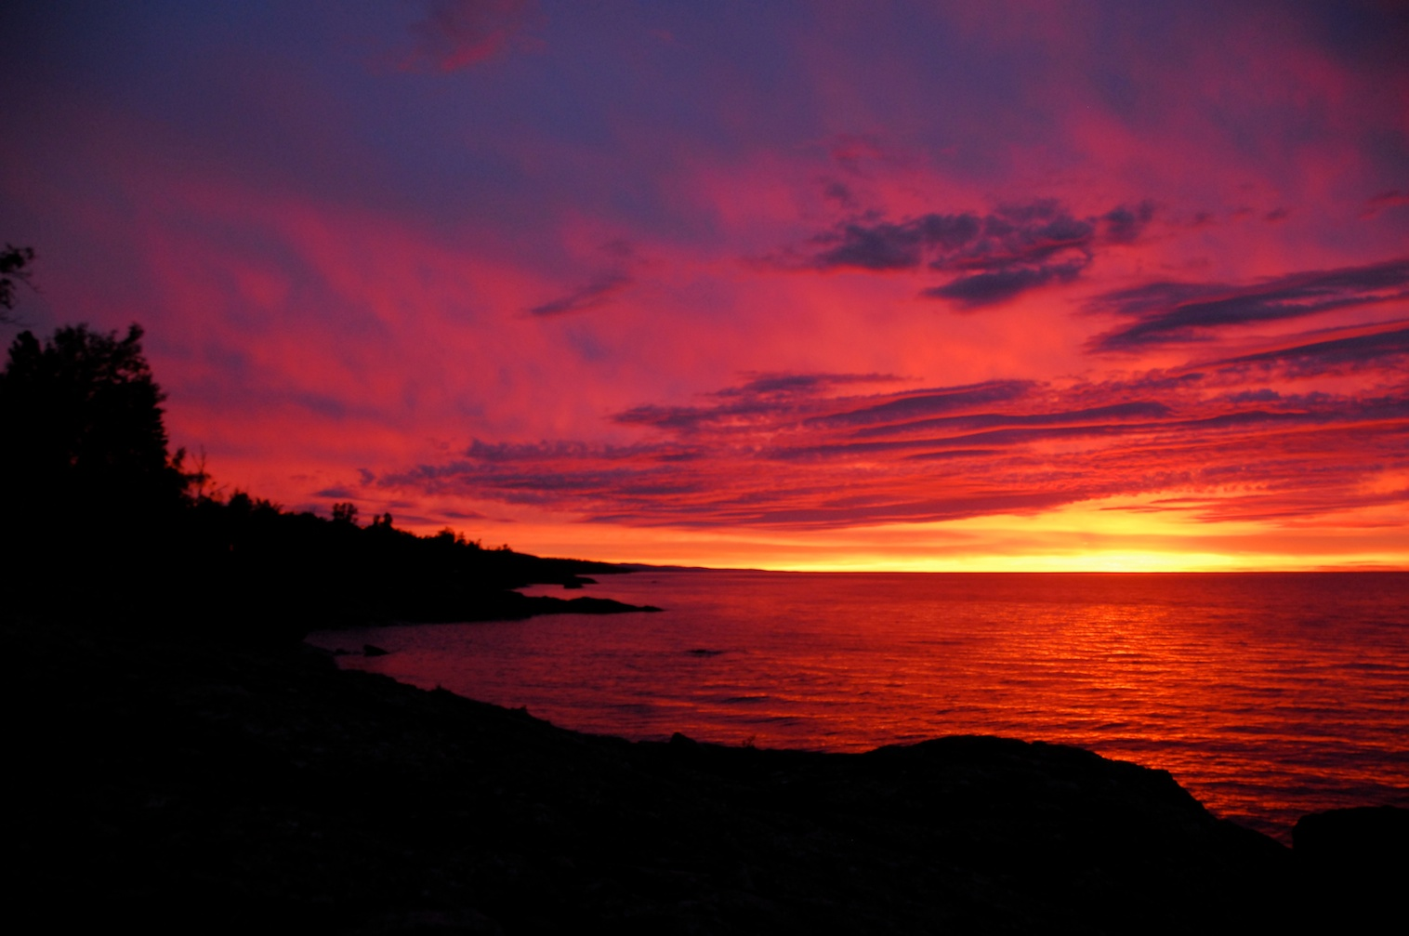

North Shore, Lake Superior

Water
Of
Life
12 September 2021

W A T E R O F L I F E

Independent Christian Church—Conservative Lutheran Doctrine

Worship Service: 9:30 a.m. Bible Study: 10:45 a.m.

Larry Cooper, Pastor E-Mail address:
111 N. Ridge Road lcooper@wateroflife.cc
Coon Valley, WI 54623 Web Site:
www.wateroflife.cc

* * * * * * * * * * * * * * * * * * * * * * * * * * *

Sermon Text: Luke 9:18-22

Tell No Man

* * * * * * * * * * * * * * * * * * * * * * * * * * *

18 And it came to pass, as he was alone praying, his disciples were with him: and he asked them, saying, Whom say the people that I am?
19 They answering said, John the Baptist; but some say, Elias; and others say, that one of the old prophets is risen again.
20 He said unto them, But whom say ye that I am? Peter answering said, The Christ of God.
21 And he straitly charged them, and commanded them to tell no man that thing;
22 Saying, The Son of man must suffer many things, and be rejected of the elders and chief priests and scribes, and be slain, and be raised the third day.

